Stefan Keller, FS 2017, updated, 27. April 2017
Kang Zi Jing, SS 2018, translated, and updated for QGIS 3.0, 22 Mar 2018

Practice – Highways

Geospatial Analysis with Vector Data and QGIS

Content
- Effects of building a motorway on habitat types
- Introduction into geospatial processing
- Working with buffers, intersections and other Geoprocessing tools

Source: This task is based on Task 6 of the course “Introduction to GIS and Digital Cartography” by Claas Leiner, University of Kassel, 2010.

Preparation

Disclaimer
This exercise has been translated from German into English, and updated for QGIS 3.0. Some of the data attributes and data files have been translated for better readability with the English speaking target group. Changes are below:
- Umgebung.gpkg to environment.gpkg
- Autobahn.gpkg to highway.gpkg
- ffh_typ_nr = ffh_Type_no.
- ffh_typ_text = ffh_Type_Text
- bfn_biotop_nr = bfn_Biotope_no.
- bfn_biotop_text = bfn_Type_Text
- geschuetzt_biotop = Protected_Biotope
- bedeutend_gruenland_type = Greenland_Intensive_Type
- gruenland_typ = Greenland_Type
- nutzung = Usage

Aims
This exercise aims to analyse and determine the natural habitats of flora and fauna specifically legally protected habitats (check Wikipedia for a page on a European law directive, FFH), which are impacted by constructing a fictitious highway.
A typical task when doing landscape planning is to determine the legally protected biotypes that would be impacted and damaged during construction. This exercise is based on the construction of the A44 motorway through the German Lambert plateau, without using real, actual data.
Data provided are a polygon vector file (umgebung.gpkg/environment.gpkg) which maps Biotype habitats, a line vector file (autobahn.gpkg/highway.gpkg) for the fictional highway route, and a topographic map (heli.tif) scaled at 1:25,000 (Tk25) to be used as a basemap. You can also use the different surface signatures (texture files) available in the work folder.
In the data table, umgebung.gpkg/environment.gpkg, the biotypes are classified under their habitat types (ffh_typ_nr/ffh_type_no) and names (ffh_typ_text/ffh_typ_text). Likewise, protected biotypes and species that thrive in rich grassland areas are classified according to the federal law (BNatSchG) (indicated in the fields “protected_biotop/protected_biotope” and “significant_gruenland_typ/significant_greenland_type” respectively).
Our aim is to determine, how many species and biotypes in the impact area of building a highway are legally protected. To do this, we have to use the Buffer Tool to identify the area of impact and then layer it over the biotype map layer to identify impacted and non-impacted areas.
The final results can be input into a table (optional).

Requirements

QGIS 3.0 (tested on QGIS 3.0)
- Material from data folder
  - umgebung.gpkg/environment.gpkg
  - autobahn.gpkg/highway.gpkg
  - heli.tif

Tasks:

Task 1: Create project file / Show the land use
- Extract the zip folder GIS_Practice_Autobahn.zip.
- Load the vector layer umgebung.gpkg/environment.gpkg onto QGIS 3.0.
- In the menu, go to Project > Project Properties > CRS (Ctrl+Shift+P), and set the Coordinate Reference System (CRS) to ESPG: 31467 (DHDN/Gauss-Krüger Zone 3) and the layer unit system to meters.
- In the menu, go to Project > Snapping Options to toggle snapping options.
- Click on Toggle Snapping (the magnet icon), change All Layers/Current Layer to Advanced Configuration, click on Topological Editing, Snapping on Intersection. Next, check the environment layer, change the type to Vertex and Segment, increase the Tolerance to 5 meters, and check Avoid Intersection. Close the dialog box.
- Save the project Project > Save As Highway and Habitat Types, and name it the same under Project > Project Properties > General.
- You can play around with the Styling of the layer and classify it by the attributes bfn_biotope_text or usage with different colors. Right click the environment layer and go to Properties > Symbology and select Categorized from the dropdown menu at the top of the dialog box.
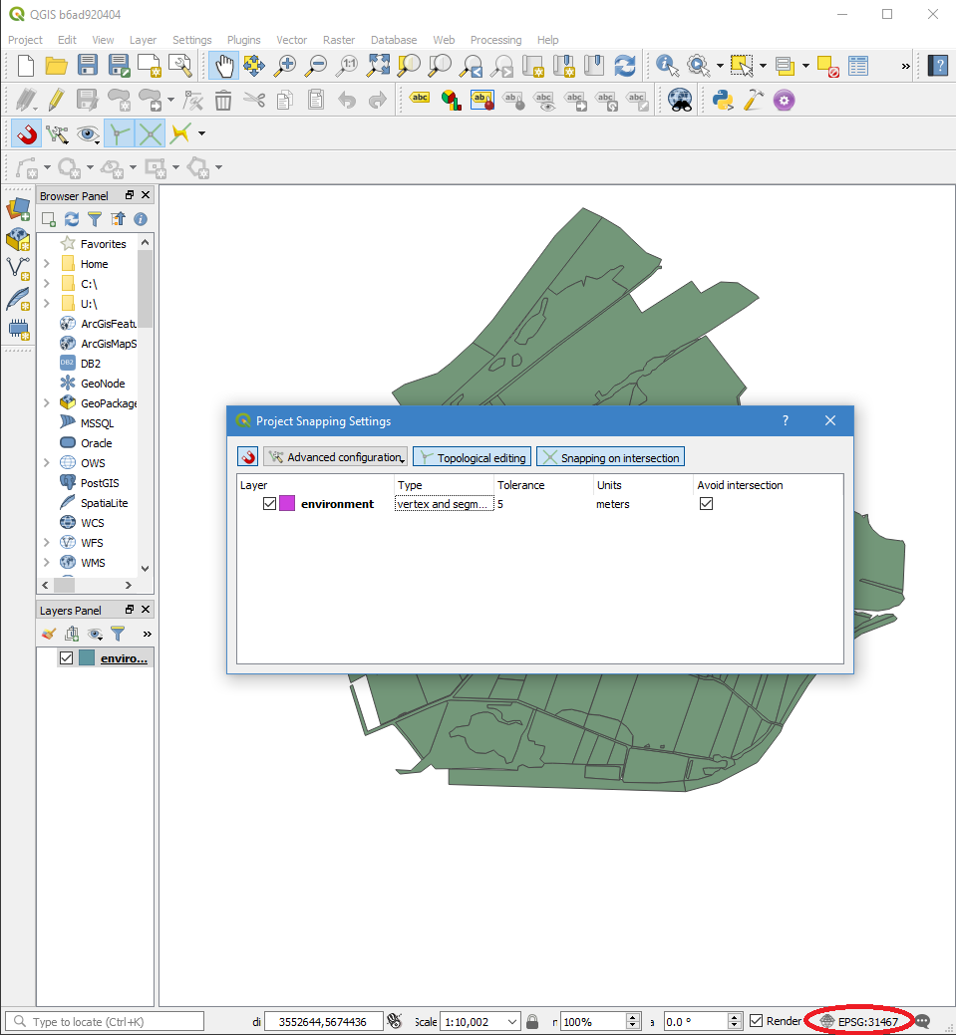
Figure: Project > Snapping Options dialog (also, make sure your CRS is set to EPSG: 31467)
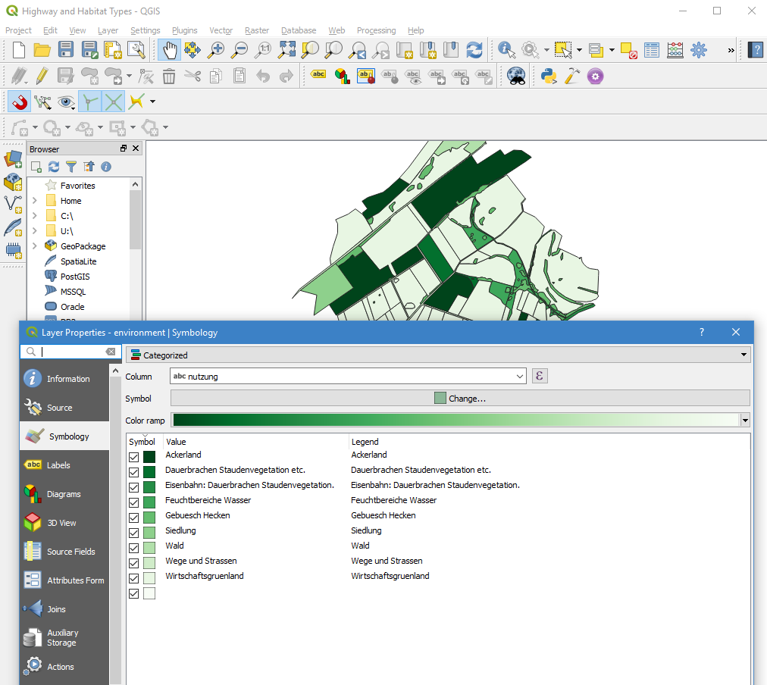
Figure: Symbology Dialog

Task 2: Load the highway shapefile and create the impact zones
- Load the highway shapefile autobahn.gpkg/highway.gpkg and make sure the line is clear and visible.
- The highway body supposedly measures 40m. As this is a 2D representation, to create the highway representation, create a buffer polygon with a distance of 20m on both sides of the line’s center.
- QGIS 3.0 moved the Fixed Buffer Distance algorithm. Go to Processing > Toolbox (Ctrl + Alt + T), if Processing is not available, make sure you install and turn on the Processing plugin under Plugins > Manage and Install Plugins. Set the Input Layer as highway, and Buffer Distance as 20. Save the result as route_20.shp, load the resulting vector and then rearrange the layers if you want.
- Now the highway shapefile will appear on your project.
- However, the impact of the highway extends beyond its physical space, thus more buffer zones have to be created.
- Create another buffer layer with a distance of 100m from the new file and name it route_20_100. This buffer identifies areas immediately adjacent to the motorway, which are likely to be affected by motor emission of noise and waste.
- Create a third and final buffer using route_20_100.shp, and input 200m in the distance field, and name the new buffer route_20_100_200.shp. This area further covers the area of intervention to a distance of 300m away from the motorway.
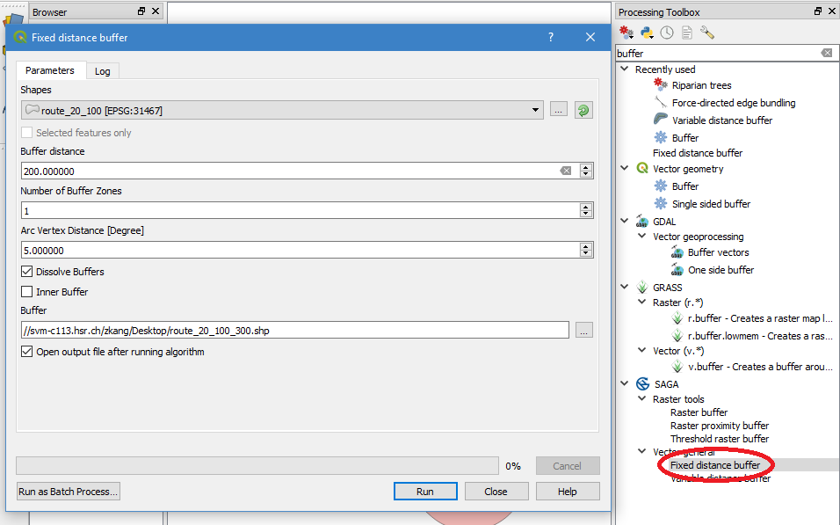
Figure: QGIS buffer creation dialog and Processing Toolbox
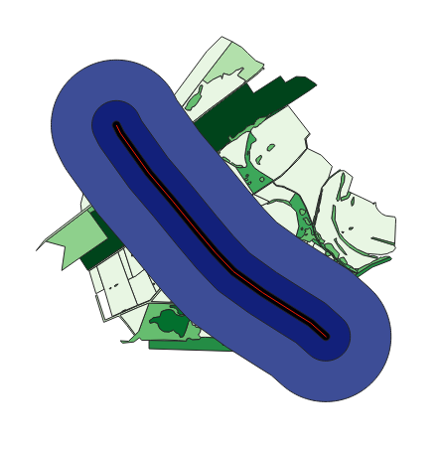
Figure: Results might look something like this

Task 3: Create exclusive rings of impact from the impact buffer zones

The newly created buffer layers cover the areas of impact, as well as the smaller inner impact areas and the actual physical highway. However, we need polygon layers in the form of contiguous zones that do not overlap. To achieve this, we use the Symmetric Difference tool. After the following processes, you will have access to the highway body as well as two separate and adjoining trays around the highway.

- Create the outer impact zone (from 100m to 300m distance from the highway) by cutting out the area of the buffer route_20_100.shp from the buffer route_20_100_200.shp to just have the external zone of impairment.
- This can be achieved with the menu option Vector > Geoprocessing Tools > Symmetric Difference
- Input layer will be route_20_100_200.shp
- Difference layer will be route_20_100.shp
- Name the output as zone_100_300.shp
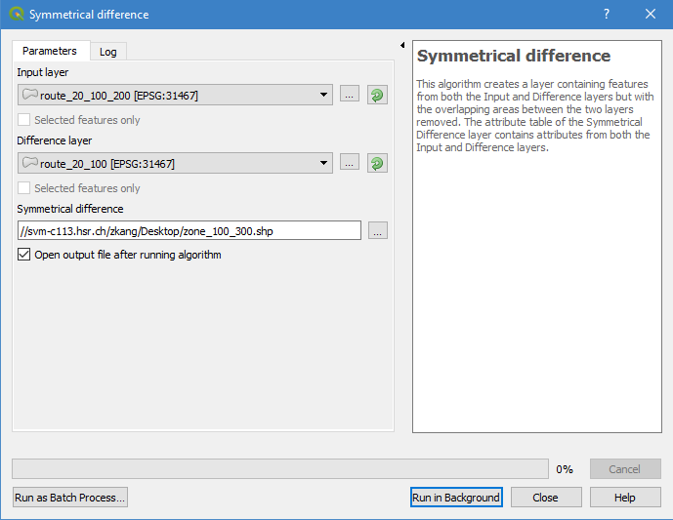
Figure: Symmetric Difference Dialog

Create an inner zone of impact (100m from the highway)
The area of the route (route_20.shp) should be cut off the buffer route_20_100.shp in order to delineate the inner impact zone. Output = zone_100.shp
The data we would be using now:
- The actual 40m wide highway route: route_20.shp
- The buffer from the highway up to a distance of 100m: zone_100.shp
- The buffer 100-300m from the highway: zone_100_300.shp

Task 4: Assemble the 3 shapefiles into 1

Merging files with the Merge function allows you to merge any number of shapefiles in one step. Unfortunately, QGIS does not have this tool. One way is to use another desktop GIS, ArcGIS. However, we can also join the three polygons using the Union tool. Since there are no overlapping surfaces, the geometry would not change. Alternatively, we could also make the layers editable and copy all polygons into a single shapefile.
A downside of the Union tool is that we can only merge 2 layers at a time, so 2 steps are needed.
- Combine the highway shapefile with the inner impact zone.
- Go to Vector > Geoprocessing Tools > Union and merge the layers route_20.shp and zone_100.shp into a new layer zones_1_2.shp.
- Union the new layer (zones_1_2.shp) with the outer impact zone (zone_100_300.shp) to the all_zones.shp layer.
- P.S. This was made more complicated than necessary – The three buffer zones created at the beginning could have been blended in 2 steps using “Union”, but we just wanted to showcase the Symmetric Difference Tool.

Task 5: Edit and label the attribute table of the vector file all_zones.shp

The new layer does not have any meaningful attribute values for the individual impact zones. In order to determine the area of differently valued biotypes in the impact zone, you must assign attribute values to the zones. As the plugin Table Manager is not available on QGIS 3.0 as of writing, right click the layer all_zones and click on Properties to edit its Attributes.
- Right click the all_zones layer and click on Open Attribute Table > Toggle Edit Mode > Delete Field.
- Add a new field named Zone, with Text (string) as its type and delete all other fields.
- Edit the layer via Layer > Toggle Editing to make it editable.
- From the menu bar, go to View > Query Objects to edit the attributes in the map view. You can edit the attributes of the respective map objects with a mouse click on an object in the map view. See Figure below.
- Click on the highway route and enter the value Route.
- Click on the middle zone and enter Inside as the value.
- Click on the outer zone with the mouse and enter Outside as the attribute value.
- You can then cut off the protruding ends of the buffer zones by using Edit > Split Objects drawing tool, selecting those protruding areas using View > Select Objects and then deleting them with the Edit > Selected Delete function.
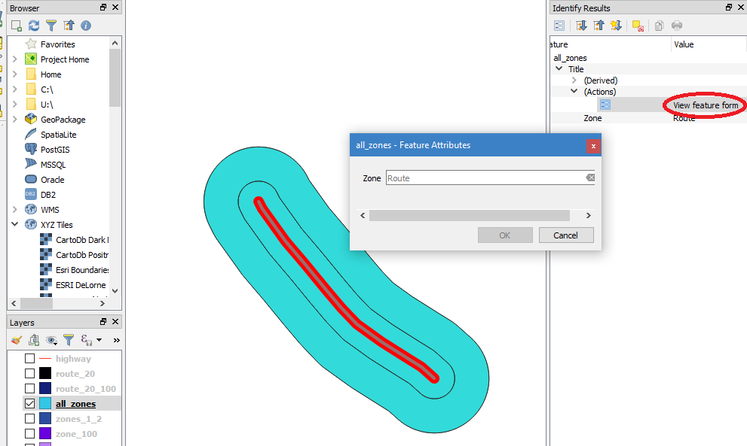
Figure: Showing how to Query and rename selected features
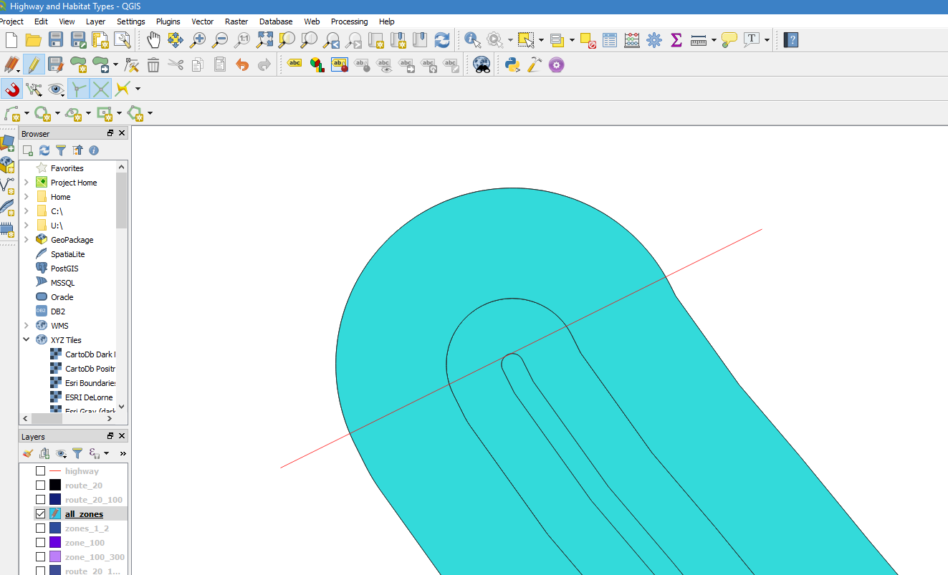
Figure: Cutting off the protruding ends of all_zones layer
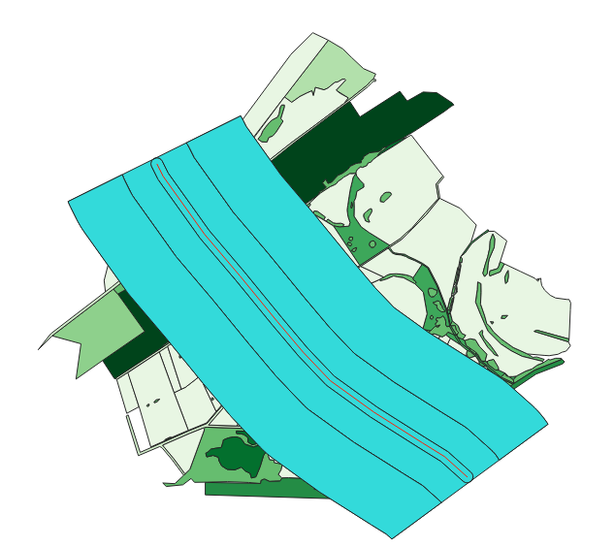
Figure: Expected result

Task 6: Querying all protected nature conservation areas

Now, query all the conservation-relevant areas from the environment layer, and sieve out protected habitats. These are the habitats protected according to Annex 1 of the Habitats Directive (ffh_Type_no.), particularly protected biotypes according to BNatSchG (Protected_Biotope) and other biotypes of grassland-rich species (Greenland_Intensive_Typ).
Follow the following steps to proceed:
- Select the layer environment in the Layer Tab.
- Open the attribute table (right click the layer > Open Attribute Table).
- Open the query editor Select Features Using an Expression.
- Compile a query that selects all the surfaces that are either FFH habitats (ffh_Type_no. = 1), includes protected biotypes (OR Protected_Biotope = 1), or that is another significant grassland types (OR Greenland_Intensive_Typ = 1).
- As the original data is in German, the aliases do not work in the Query Selecter, instead, use their original names. Your SQL command must look like this: ffh_typ_nr = 1 OR geschuetzt_biotop = 1 OR bedeutend_gruenland_typ = 1
- Test the query and select show only selected features, the selection should contain 43 polygons.
- Confirm and exit the attribute table. You have now selected all the areas that are crucial to preserve biotypes and species.
- Save the selection via right clicking the environment layer > Save as under the name valuable.gpkg and saving only selected features.
- You now have a shapefile of only the protected habitats.

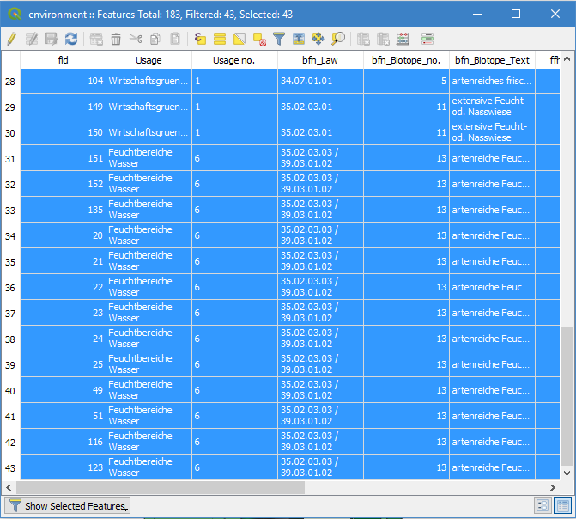
Figure: Open Attribute Table Dialog

Task 7: Intersection between valuable areas and impact zones

Next, we have to determine which of these protected areas fall within the three zones of impact. Use the Intersect Tool to intersect the valuable and all_zones layers. The resulting layer contains only areas that are valuable in terms of nature conservation and that are simultaneously destroyed or impacted by the construction of the highway.
- Use the menu option “Vector > Geoprocessing Tools > Intersection” to intersect both layers.
- Input Layer: all_zones, Layer cut: valuable
- Output: intersect_valuable.shp
- If there is an error about an invalid geometry, go to Settings > Options > Processing > General > Invalid Features Filtering -> Ignore Features with Invalid Geometries.
- In the attribute table of the layer intersect_valuable, go to Layer > Open Attribute Table > Field Calculator in the upper right corner. This allows you to create a virtual field based on an “expression”. Use the expression below to use QGIS to calculate the area of our polygon, which is then divided by 100 to convert the square meters to acres. The result is finally rounded to 1 significant figure.
- Expression: round($area/100, 1).
- Set Output field name as area and select the Output Field Type as Decimal number (real). Confirm and check that a new column titled “area” has been created.
- The exact areas of the polygons are stored in the column named area.

Task 8: Categorize and stylize vector files and create maps

You have now finished doing most of the analysis, and can now display your new geometry layers as informative maps. Make them represent the valuable biotopes in the impairment zones or the conflict zones in a map.
- Categorize intersect_valuable.shp by ffh_Type_Text (about 4 attributes).
- Delete the empty rows.
- The layer now represents all areas within the impairment zones on which FFH-relevant biotypes are located.
- Load the attribute table of the layer and use the query editor to create the query ffh_Type_no. = 0.
- Save the selection via Layer > Save as under the name intersect_valuable.ffh.shp
- Load the new layer and categorize/stylize it for bfn_biotop_text.
- Delete the empty values and categorize/stylize it for bfn_biotop_text.
- Load the enclosed raster file heli.tif and then move it to the bottom of the table of contents. Then, adjust the global transparency in the layer properties of heli.tif so far that the raster layer can serve as a faintly visible background.
- Now you can create a map that represents the valuable biotypes affected by the motorway construction and additionally emphasize the ffh_Type_no.
- Create a map layout and export it as a PDF. (Activate in general under “Print as raster”)
- An example of a possible map display can be seen on the following page. However, you do not have to create a two-card layout. It is enough if you decide on a substantive statement and visualize it in a meaningful map layout.

Conclusion
You will end up with the following files:
- The simple biotype card
- A ready-made map layout in PDF format, which represent either the valuable biotypes in the impact are or the conflict zone in terms of biotype and species conservation

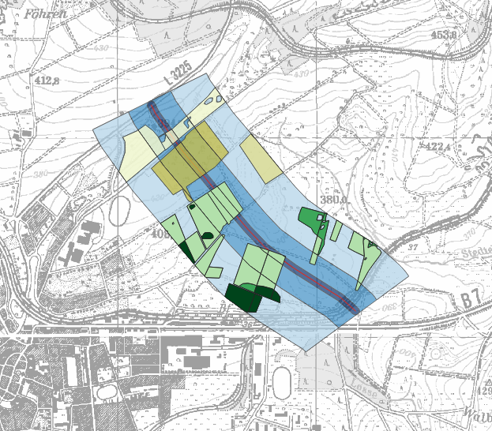
Figure: End result in QGIS 3.0
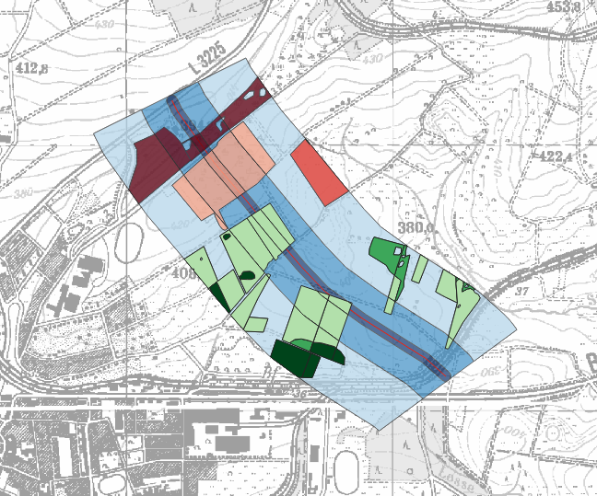
Figure: End result, green polygons are protected habits, red are non-protected

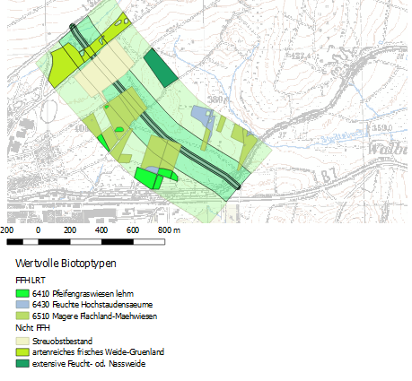
Figure: End result in QGIS 2.18

[]

